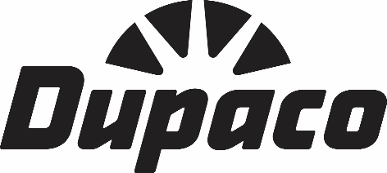
2021 Dupaco Key City Creative Center
Scholarship Program Rules
The Dupaco Community Credit Union partnership with Key City Creative Center (KCCC) will award two, non-renewable, annual memberships to individuals to develop their skills, training and/or startup business.
I. Eligibility
A. Entrants must complete the contest application and meet KCCC membership guidelines to be eligible for the contest.
B. Limit of one individual membership per winner.
II. Entry Requirements
- Application process will be completed in two rounds to ensure applicant meets guidelines set forth by Dupaco and KCCC.
  - Round 1: All entrants must complete a questionnaire administered by Dupaco Community Credit Union. Questions will be:
A makerspace is a unique collaborative space where individuals gather to create, learn and share ideas. Membership provides an opportunity to improve and develop your personal skillset while sharing knowledge and skills with other members.
    - What skill(s) do you hope to learn or enhance with a KCCC membership? What is your plan to sustain that skill long-term?
    - What skill(s) do you currently have that you would be willing/able to share with other members?
    - If awarded, what type of projects do you aspire to complete during your membership?
    - If awarded, how would you share the results and outcome of your annual membership?
Applicants will be judged by two representatives from Dupaco and one representative from KCCC.
  - Round 2: Two individuals will be chosen to move onto Round 2. Applicant must formally apply for KCCC membership and meet their guidelines for membership. This step must be completed in order to finalize application. That process includes:
    - Complete KCCC membership application.
    - Set-up appointment for in-person tour of KCCC, which ensures a chance to answer any questions and adequately review KCCC policies.
- The initial application for Round 1, can be found online at www.dupaco.com/keycity.
- Round 1 applications are due by 5:00 p.m. (CT), Tuesday, November 30, 2021. Incomplete applications not fulfilling the entry requirements will not qualify to move onto Round 2.
- Round 1 applications will be managed and distributed by Dupaco.
- Applicants selected for Round 2 will be required to complete KCCC membership application.
- Applicants selected for Round 2 will be notified on or before December 10, 2021.
- Winners selected for an annual membership will be notified on or before Monday, December 20, 2021.
III. Judging
- A panel of judges will be selected from both Dupaco(2) and KCCC(1).
- Judges will take into consideration:
  - The applicant’s desire to improve skills.
  - The applicant’s goal and plan for skill sustainability.
- Judges will select the top two applicants to move onto Round 2. If an applicant is not able to complete Round 2 criteria, judges will select the next available applicant.
IV. Authority of Dupaco Community Credit Union and Key City Creative Center
A. Dupaco Community Credit Union and Key City Creative Center have the authority to amend any of the above rules to ensure fairness in the awarding of the membership.
B. Any questions regarding the KCCC Membership program should be emailed to marketing@dupaco.com.

